

DSA DATA ANALYSIS CAPSTONE PROJECT

CASE STUDY 2: KULTRA MEGA STORES (KMS) INVENTORY



July 4, 2025

JONATHAN OMHANS OKHUNKHUN

LAGOS, NIGERIA

**DOCUMENTATIONS ON KULTRA MEGA STORE (KMS) DATA ANALYSIS**

**OBJECTIVE:**

The objective of the analysis is to assess the company’s sales performance with respect to product categories and regions. Also to provide useful insights and findings to support management decision in expanding revenue and customer base.

**PART 1:** CREATE DATABASE AND INVENTORY TABLE FOR KSM.

**STEPS:**

1. Launch your SQL Server Management Studio (SSMS)

2. To import the inventory table into SSMS; right-click on the KSM_DB you've created.

3. Click: Tasks → Import Flat File...

4. In the wizard: Browse and select your KMS Sql Case Study file which has been renamed as "Inventory"

5. Click Next, check the column mappings.

6. Modify the datatype where necessary to suit your need. (I modified columns; Order ID, Discount, Profit, Unit Price, Shipping Cost, Sales, and Product Base Bargain to Int, Decimal (6,2), money, Smallmoney, Smallmoney, Decimal (10,2) and Decimal (6,2) respectively). And Set Row ID as the Primary Key.

7.Click Finish to complete the import.

PART 2: RUN ANALYSIS FOR SCENARIOS 1 & 2

**A. SCENARIOS 1 (NB: Sales are Dollars- $):**

**1.** Which product category had the highest sales? = **Technology**

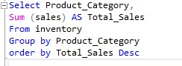 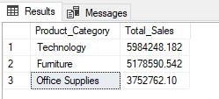

**2. (a)** Top 3 regions by sales = **West, Ontario, Prarie.**

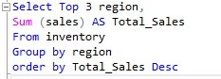 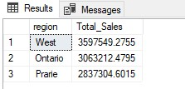

**(b)** Bottom 3 regions by sales = **Nunavut, Northwest Territories, Yukon.**

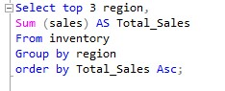 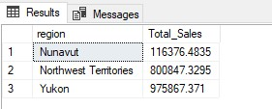

**3.** Total sales of appliances in Ontario = **$202,346.84**

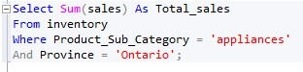 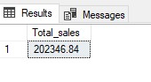

**4.** Advice on how to increase revenue from the bottom 10 customers;

(a) Bottom 10 customers

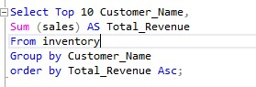 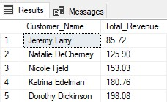 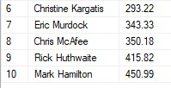

(b) Analysis shows that the bottom ten (10) customers have very low number of orders ranging from 1-4. Secondly, they buy more of low-cost products. Therefore, in order to increase revenue from them, Management is advised to sell more of high-cost products to them, and offer them more discounts to lure them to place more orders.

**5.** KSM most shipping cost and the method = **Delivery Truck ($51,971.94)**

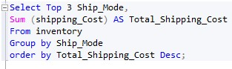 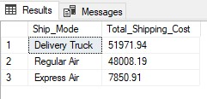

**B. SCENARIOS 2:**

**6.** Most valuable customers and the products/services they usually purchase

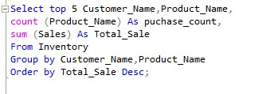

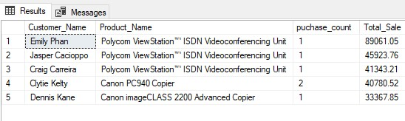

**7.** Small business customer with the highest sales = **Dennis Kane ($75,967.59)**

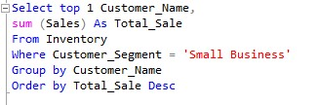 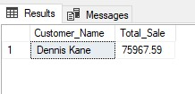

**8.** The Corporate customer with the highest orders = **Adam Hart (27 Orders)**

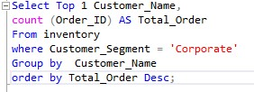 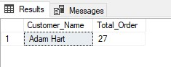

**9.** Consumer customer that's most profitable =

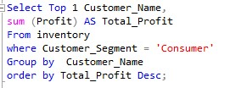 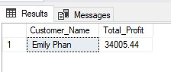

10. Customers that return items and their segments. = 989 Customers returned items. The First 20 and last 11 of these customers and their segment are shown below;



**The first 20 Customers** **The last 11 Customers**

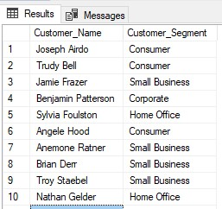 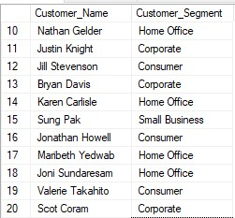 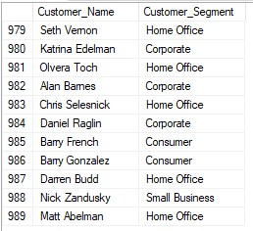

**11.** If the Delivery Truck is the most economical but the slowest shipping method and Express Air is the fastest but the most expensive one, **the Company did not appropriately spend Shipping costs because of the query result below;**

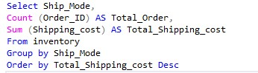 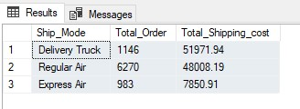

*And* a further analysis shows that the Company incurred an average cost of $45.35 per order using Delivery Truck (which is expected to be lower) whereas it incurred an average cost of $7.99 using Express Air. See details on the table below;

|  |  |  |  |
| --- | --- | --- | --- |
| **Ship Mode** | **Total Orders** | **Total Shipping Cost** | **Average Shipping Cost** |
| Delivery Truck | 1146 | $51,971.94 | $45.35 |
| Regular Air | 6270 | $48,008.19 | $7.66 |
| Express Air | 983 | $7,850.91 | $7.99 |